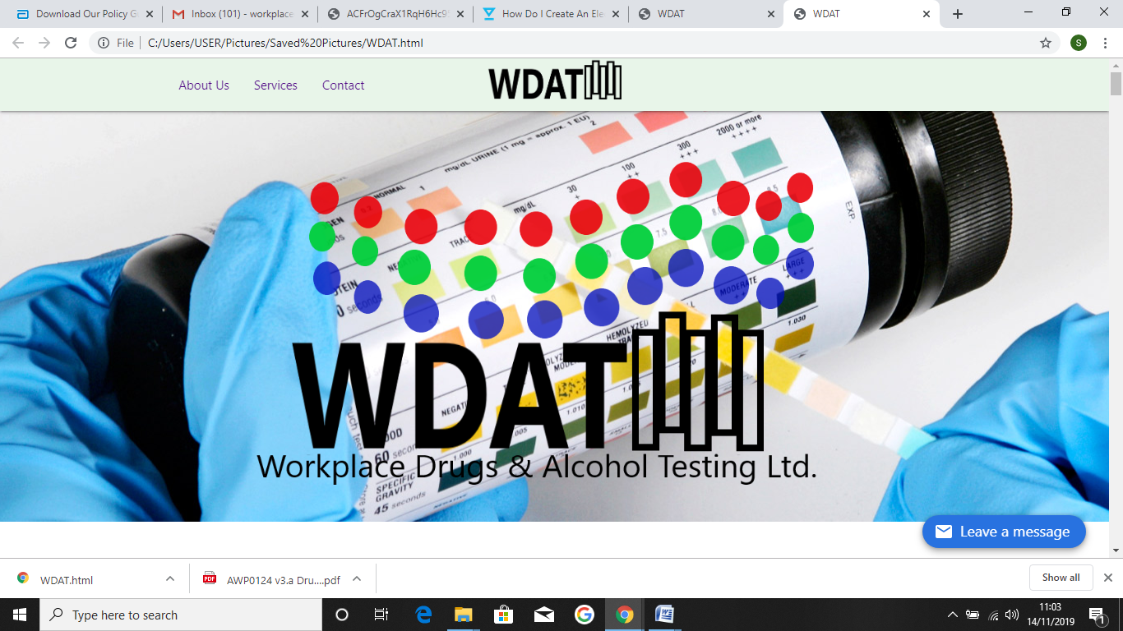

**GDPR Policy**

**Workplace Drugs and Alcohol Testing Ltd (WDAT) - GDPR policy 2020**

The General Data Protection Regulation (GDPR) is a regulation of the European Parliament, the council of the European Union and the European Commission intended to strengthen and unify data protection for all individuals within the European Union (EU) and became law in the UK on 25th May 2018. Under the GDPR, we are required to publish information about what data we collect, why we need to store it, and your rights under the GDPR legislation.

**Confidentiality**

Workplace Drugs and Alcohol Testing Ltd falls into the category of medical info, which requires a lawful basis for collection and processing of data. We have always and will continue to, treat all data we receive and information submitted to us as strictly confidential. How to contact us You can contact us by visiting our website; www.workplacedat.co.uk or email us; [workplacedat@gmail.com](mailto:workplacedat@gmail.com).

**Purposes and legal basis for processing**

The purpose of us processing your personal data is through a request to perform a drugs and alcohol screening test from either your employer or agency that you currently work for. This will be in line with their health and safety policy, in response to a need for screening for; pre-employment, random or for cause. We always ask for consent and read out our declaration to you before starting any screening test. We always ask if you understand and if you are happy to sign the consent form after we have read the declaration to you.

We only process a person's personal data for one or more of the following reasons; 1. We have your written (signed) consent (please see appendix 1 - declaration screening form.)

2. We need to process your data in order to full our obligations to the contractor (e.g. Employer).

3. We are legally required to process your data.

4. If failing to process your data could put yours or someone else's life at risk.

**Data we hold**

The data we hold consists of:

**Contact information**

Your name, employer or company name, postal address (if applicable), email address (if applicable), telephone number (if applicable), job title, D.O.B (date of birth), gender, ID e.g. Passport or driving licence number for identification purposes, medication used in the last two weeks, screen test for drugs (negative or non-negative and for what substances) and breathalyser results (up to 4 readings).

This data is used to identify you, record the screen results and contact you if, with your consent, a chain of custody laboratory screen is carried out.

**Payment information**

This is not held for individuals whom are being screened, only for clients whom we invoice after works have been completed. This information is deleted upon completion of a contract or at the clients’ request (if applicable/ legally able to).

**Enquiries**

Any enquiries we have will have been received via email or post. Enquiries via email, once read and acted upon, unless still relevant to an ongoing contract, implication or tax record will be deleted after 12 months.

**Retention policy**

We store and process data only as agreed by the client or as required in order to perform services requested by the client. We regard all details that we store as confidential. We will keep hold of your data for no longer than necessary. We only store personal data for as long as is legally required and for as long as we have your consent. We retain personal data that you supply to us, for as long as you (contractor and employee) are a client with an active account, and for as long as we are legally required to do (e.g. For tax and accounting regulations).

**Recipients’ data sharing**

We do not sell any of your personal data or engage in any poling activities. To be able to provide our services to you and run our business effectively, we share data with 3rd parties from the following categories;

* Contractors that we perform the drugs and alcohol testing for, in line with their health and safety policy (your employer/ agency).
* Law enforcement and other government authorities e.g for tax purposes or legal reasons.

For the purposes of GDPR regulations - We do not transfer data to any third country.

**Your rights**

1. **To be informed**.

We must inform you of how we are going to use your data. We do this through this policy and by informing you of how your data will be used each time we collect it.

2. **Right of access and erasure**.

You have the right to access your personal data that we hold. This is called a subject access request. We aim to respond to every request within one month. If you think the data we hold is incorrect, tell us so we can put it right. You have the right to request that we delete your data. We will do so, providing that we do not have a compelling or legal reason for keeping it. To request access, rectify something or to request the deletion of your account please email us at [workplacedat@gmail.com](mailto:workplacedat@gmail.com). If you require a copy of your drugs and alcohol test please do so by emailing us at [workplacedat@gmail.com](mailto:workplacedat@gmail.com) and we will ask for confirmation of your date of birth and ID related number you provided during your test. We will then (with your consent) email your certificate to you.

You also have the right to raise any issues or concerns to us, please do this directly to [workplacedat@gmail.com](mailto:workplacedat@gmail.com).

3. **Consent and withdrawal**

You have a genuine, free choice to either consent or not consent to us performing a drugs and alcohol screening test (see Appendix 1). We will offer you both options after reading the declaration form and you will be conforming that you fully understand the process of consent/ not consenting through signing this form. We acknowledge your consent when you voluntarily sign and date the sample donor section, sign and date the alcohol screen results and similarly the drug testing results section. As outlined in your employer/ agencies policies a refusal / deliberate attempt to tamper with the samples or delay testing may constitute a breach of your employment and would therefore be actioned as a refusal.

Similarly as you are able to refuse consent, you are also within your rights to withdraw consent after you have agreed to it. You can do this by informing the tester throughout the process of your intention to withdrawal.

This policy has been prepared and signed by;



**Sarah Ketley**

**Managing Director WDAT**

**Date: Revised November 2020**